Data Processing Unit Board

Testing Guide

Version | Update Date | Author | Memo
V0.0.1 | November 5, 2025 | Anonymous | Initial Version.

1. Hardware Preparation
This guide demonstrates how to test the DPU board in comprehensive. Although this board is designed to get power supply from PoE (Power Over Ethernet), it also can be powered from lab power supply. Before testing, please make sure all components below are ready.

No. | Components Name | Memo
1 | DuPont Wire | Connect DPU Board to Lab Power Supply
2 | DPU Board | One piece of DPU Board
3 | Ultrasonic Sensor PreAMP Board | One piece of Ultrasonic Sensor PreAMP Board
4 | Oscilloscope | Check waveform.
5 | Oscilloscope Probe | Probe x10
6 | Digital Multi-meter | Flue Multi-meter
7 | Lab DC Power Supply | 5V Voltage Source
8

2. Hardware Connection

2.1 Connect DPU board to Lab DC Power Supply with DuPont Wire.
Ensure the correct pinout before connecting. The left pin is 5V, the middle one is floating, the right is GND. Warning, no polarity protection circuit on board due to PCB size.

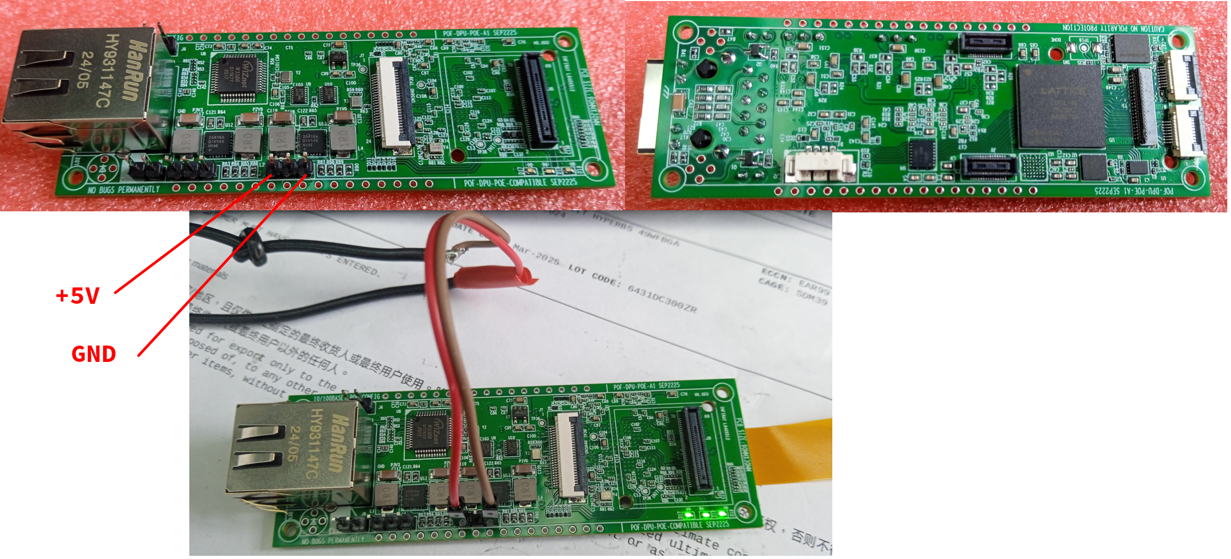

2.2 Set Lab Power Supply Over Current Threshold and Power On
At the 1st time, set a lower over current threshold in order to cut off power supply immediately in case of short-circuit. Experience shows 200mA is appropriate. The current consumption accelerates as FPGA logic expands.

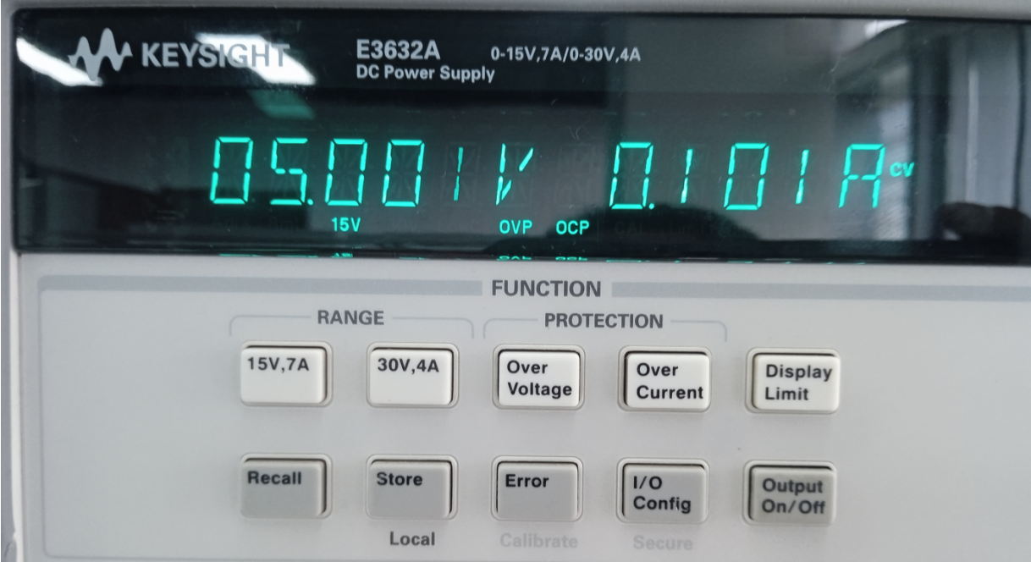

3. Power Rails Ripple Voltage Test

3.1 P3V3 Ripple Voltage
Measure P3V3 power rail ripple voltage at the point described below. Avoid long ground loops when using an oscilloscope probe. Vpp<=22.74mV

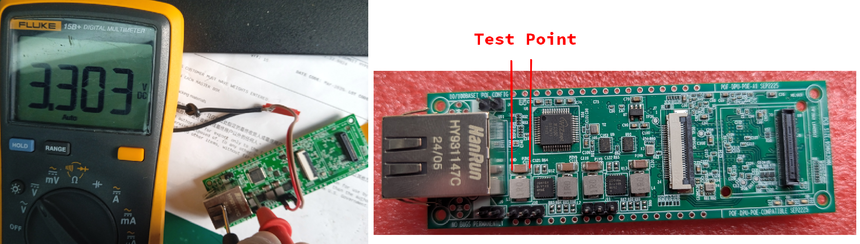

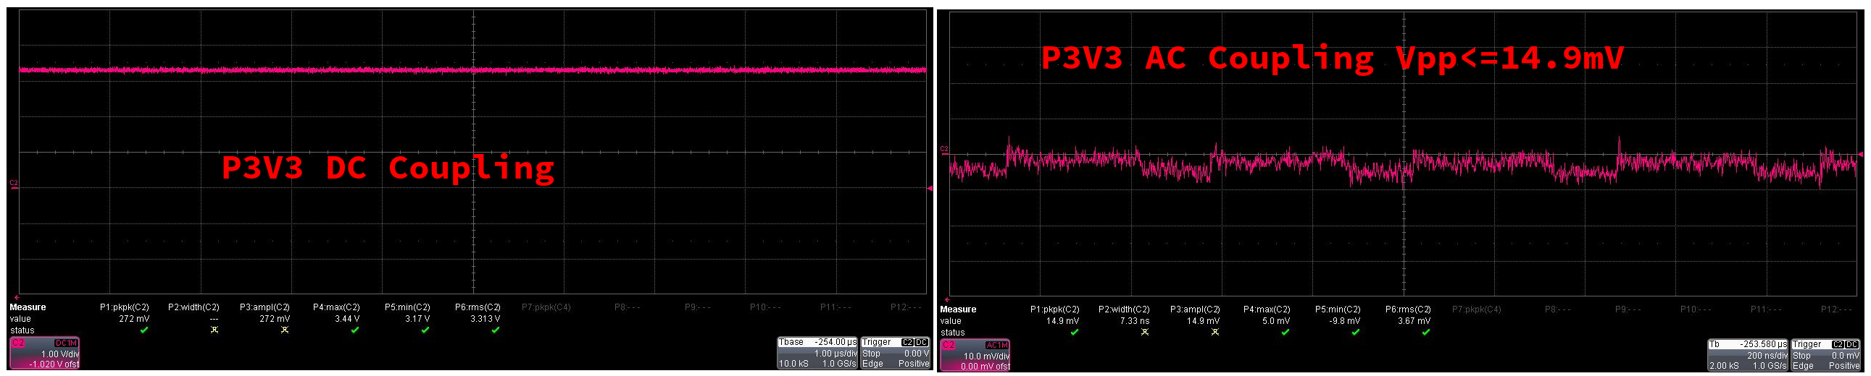

3.3 P2V8

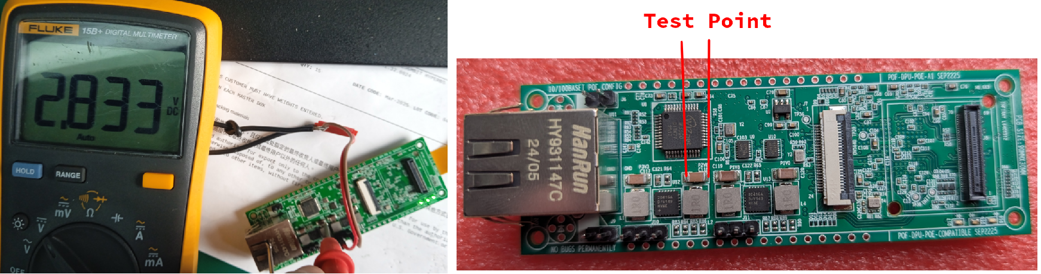
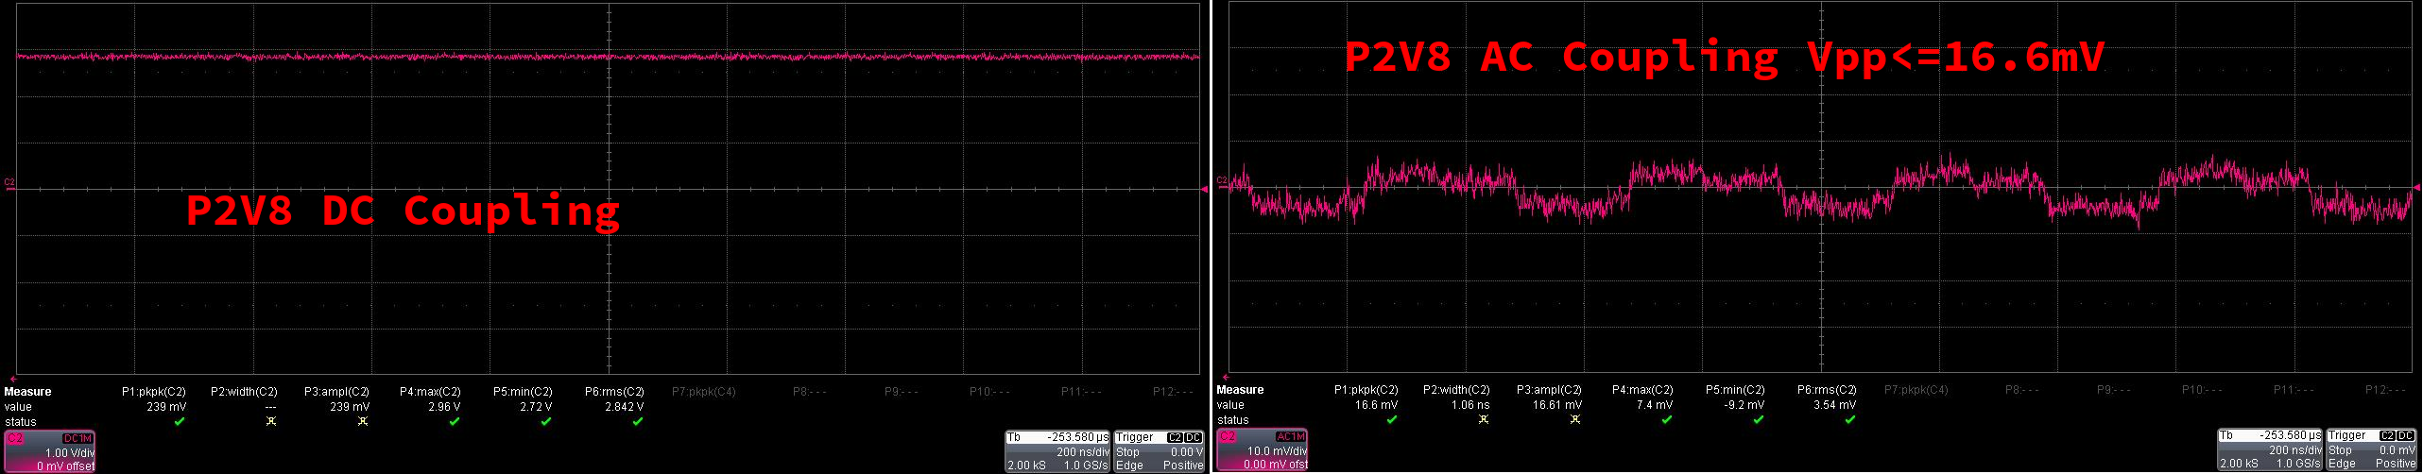

3. 4 P1V8

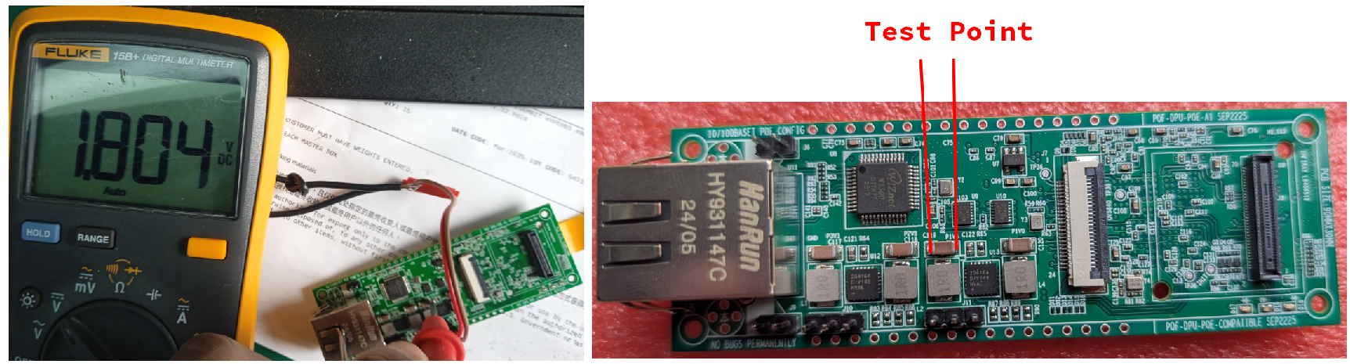
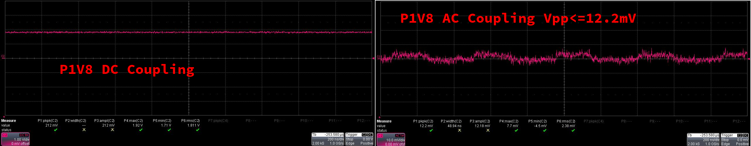

3.5 P1V0

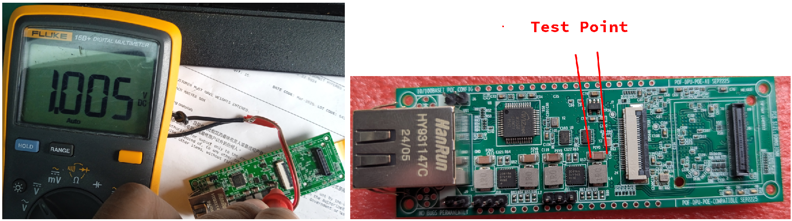
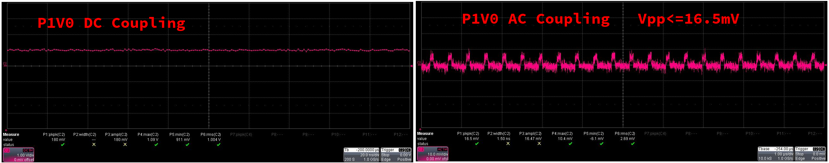

3.6 P1V5

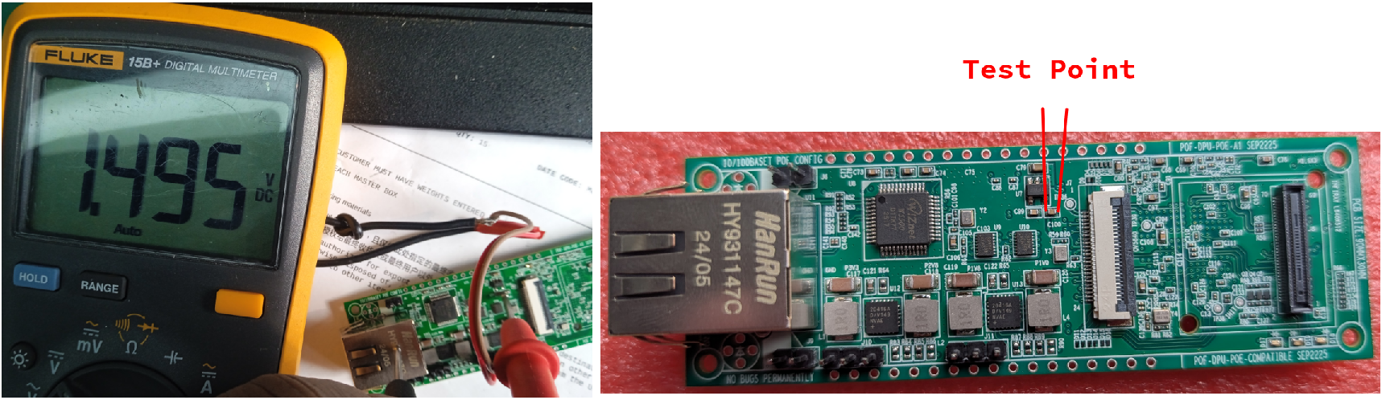
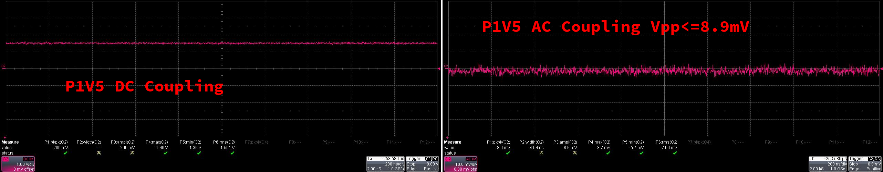

4. Oscillator Frequency Test
4.1 FPGA External Clock – 25.0MHz

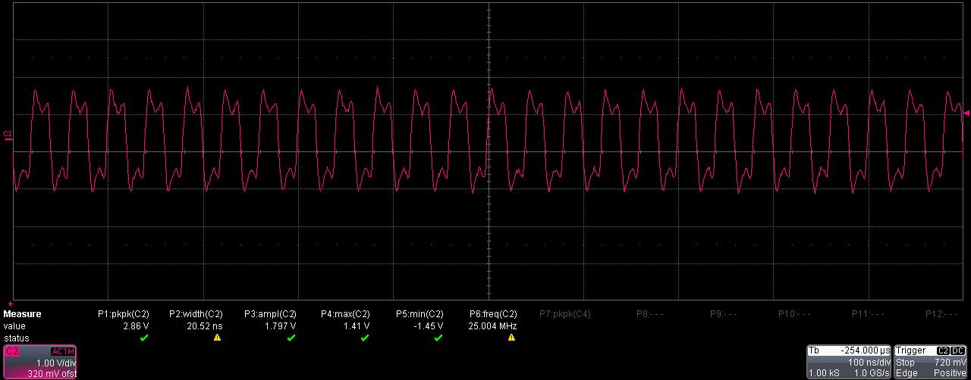

4.2 OV5640 Clock – 24.0MHz

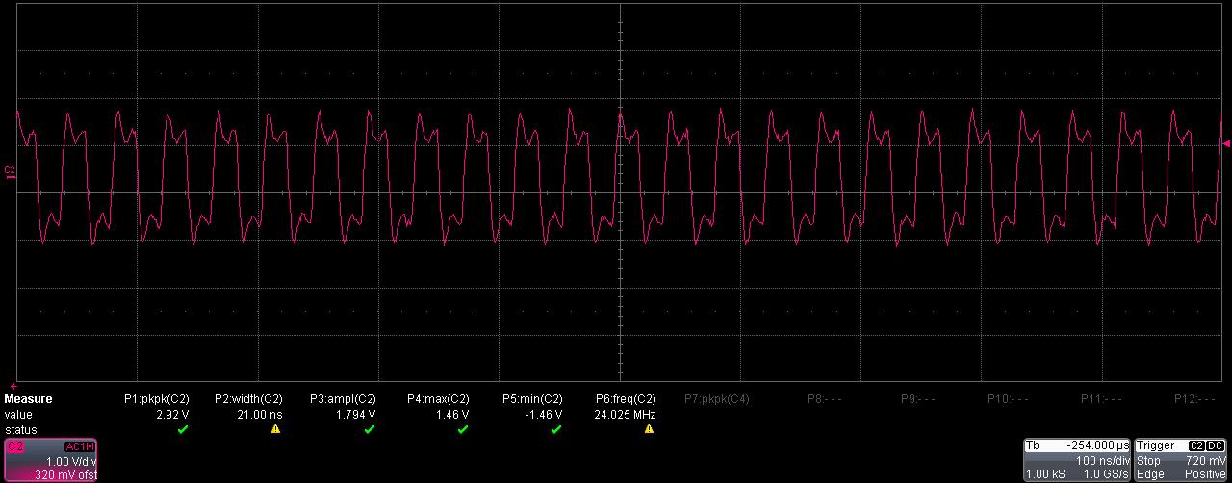

4.3 W5500 Clock – 25.0MHz

Signal is biased to DC 1.25V to match ADC full scale range. So alternative signal can swing in range 0~2.5V. Set oscilloscope to DC 1M-OHMS coupling, you can observe DC offset obviously.

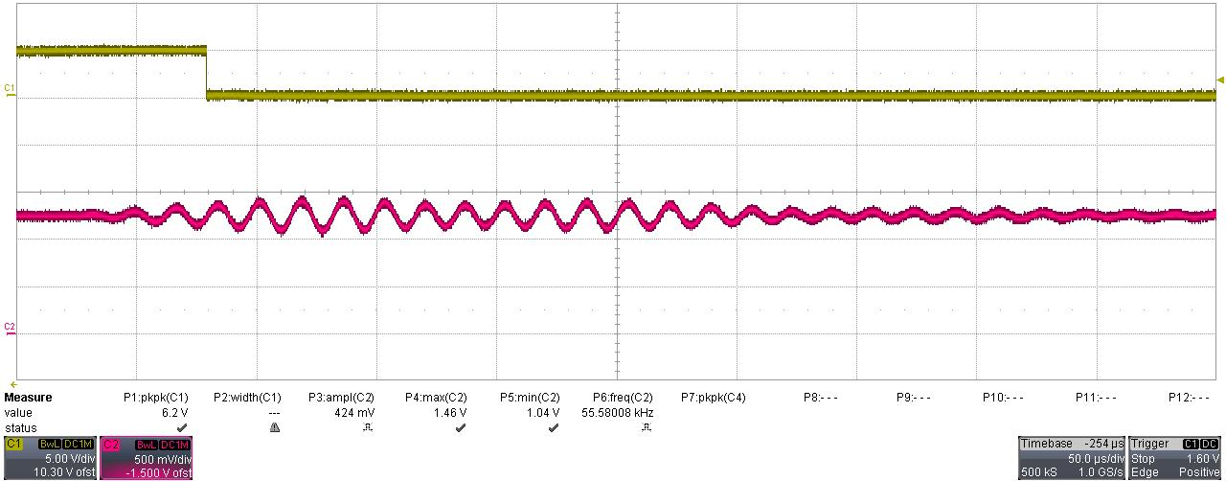

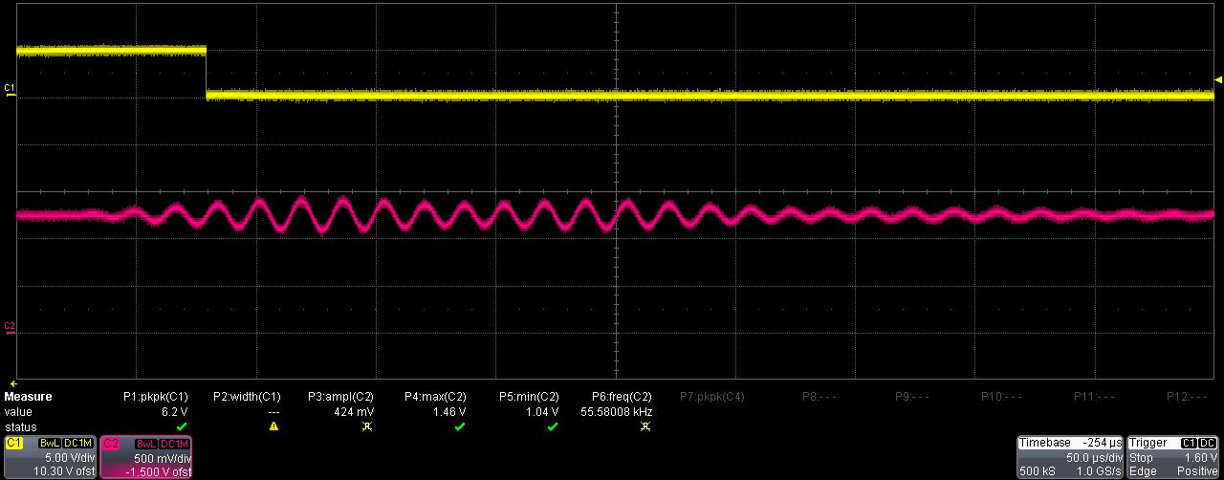
5. Frequency Response Graphs

WARNING:
The amplitude of waveform is affected by angle, distance and transmit strength. Following graphs are only reproduced in specified conditions.

5.1 Test Condition: 10KHz, 2.5Vpp, Cycles=5, Duty Cycle=10ms, Gain=100.

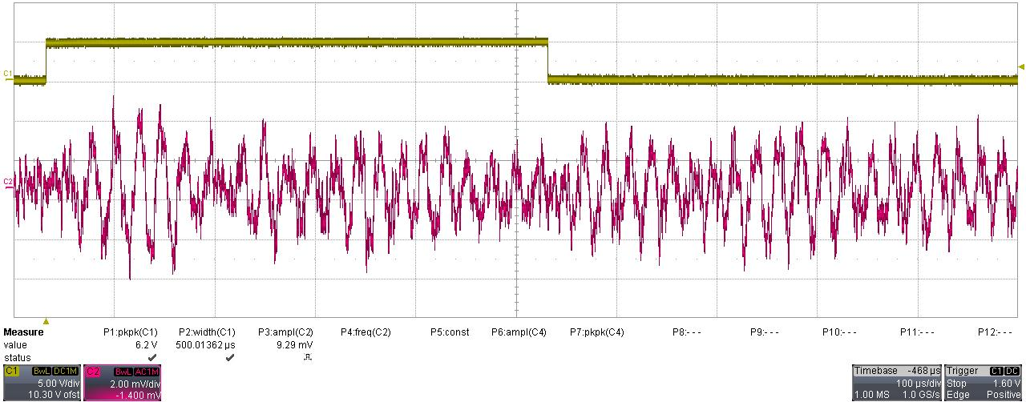

5.2 Test Condition: 20KHz, 2.5Vpp, Cycles=5, Duty Cycle=10ms, Gain=100.

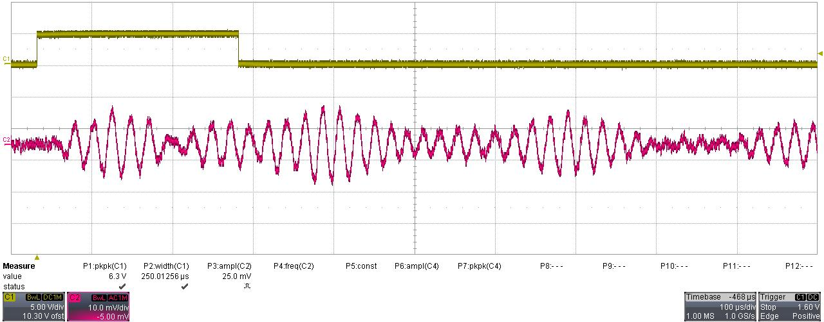

5.3 Test Condition: 30KHz, 2.5Vpp, Cycles=5, Duty Cycle=10ms, Gain=100.

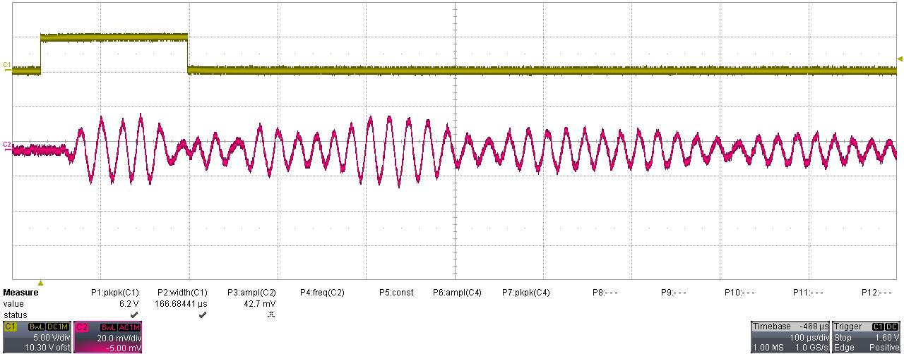

5.4 Test Condition: 40KHz, 2.5Vpp, Cycles=5, Duty Cycle=10ms, Gain=100.
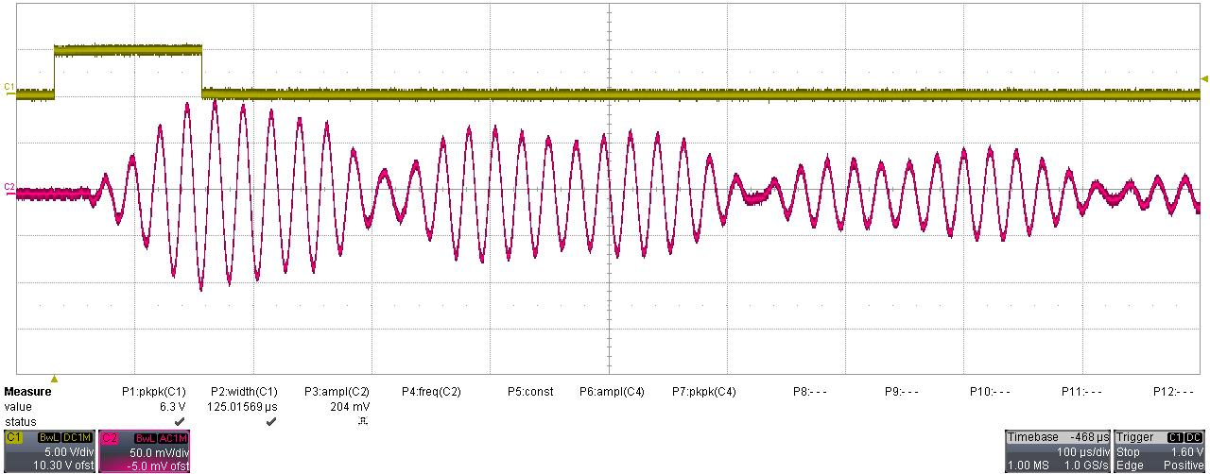

5.5 Test Condition: 50KHz, 2.5Vpp, Cycles=5, Duty Cycle=10ms, Gain=100.

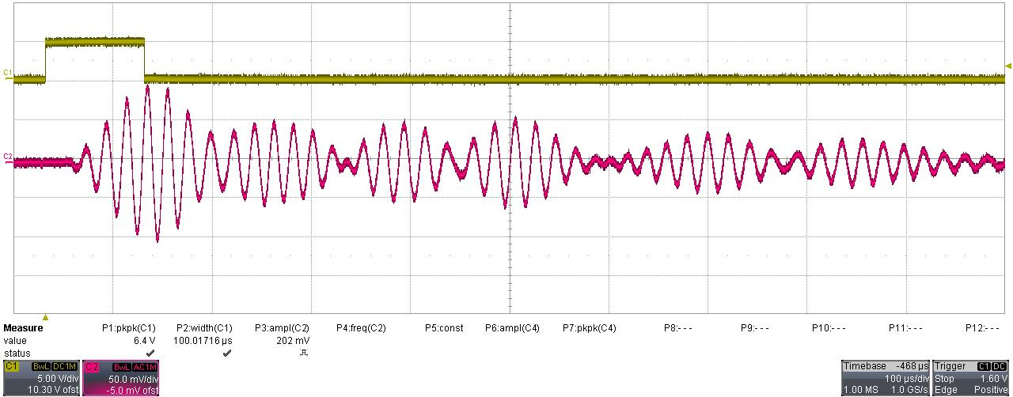

5.6 Test Condition: 60KHz, 2.5Vpp, Cycles=5, Duty Cycle=10ms, Gain=100.

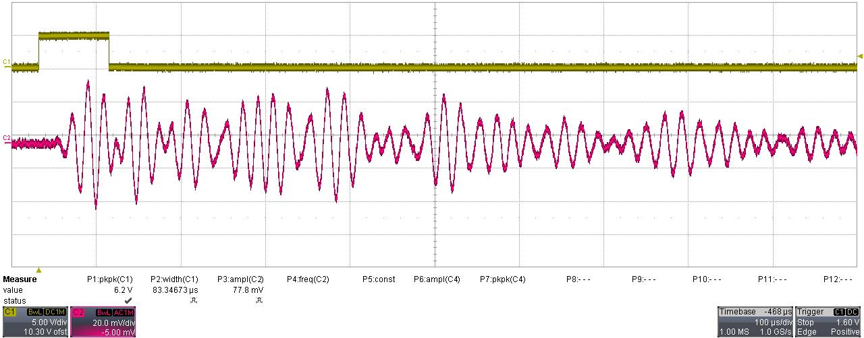

5.7 Test Condition: 70KHz, 2.5Vpp, Cycles=5, Duty Cycle=10ms, Gain=100.
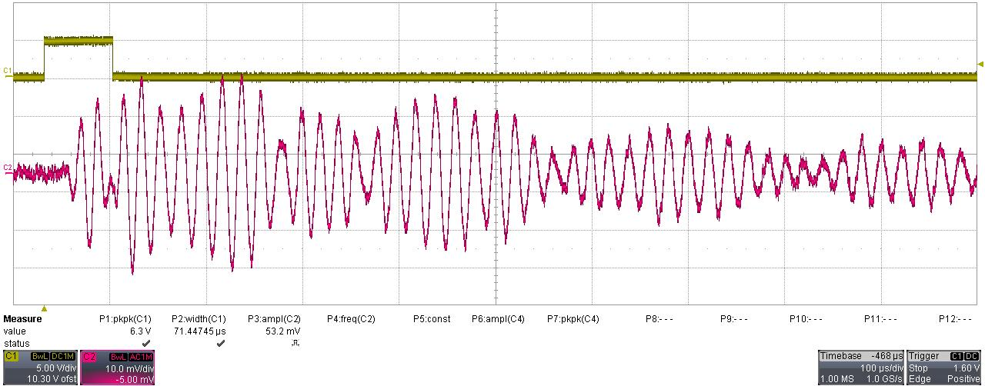

5.8 Test Condition: 80KHz, 2.5Vpp, Cycles=5, Duty Cycle=10ms, Gain=100.

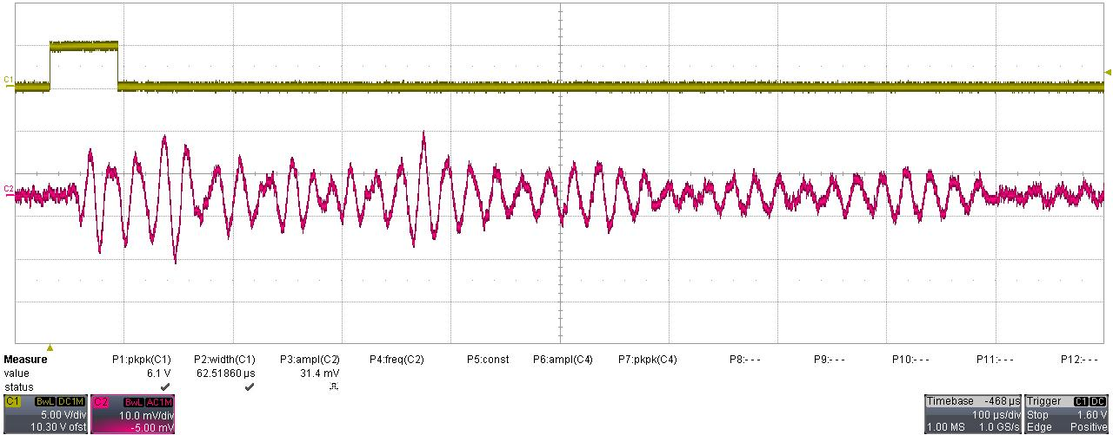

5.9 Test Condition: 90KHz, 2.5Vpp, Cycles=5, Duty Cycle=10ms, Gain=100.

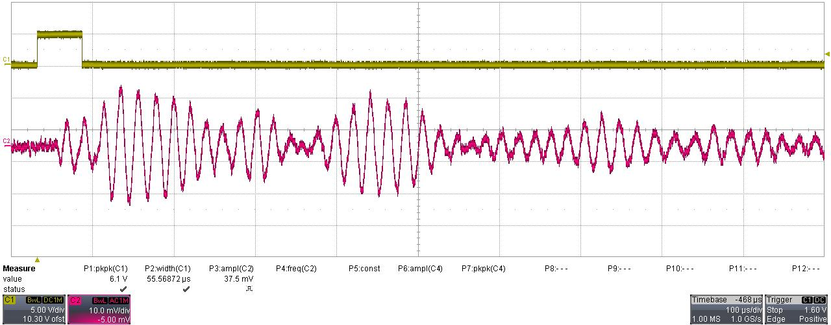

5.10 Test Condition: 100KHz, 2.5Vpp, Cycles=5, Duty Cycle=10ms, Gain=100.
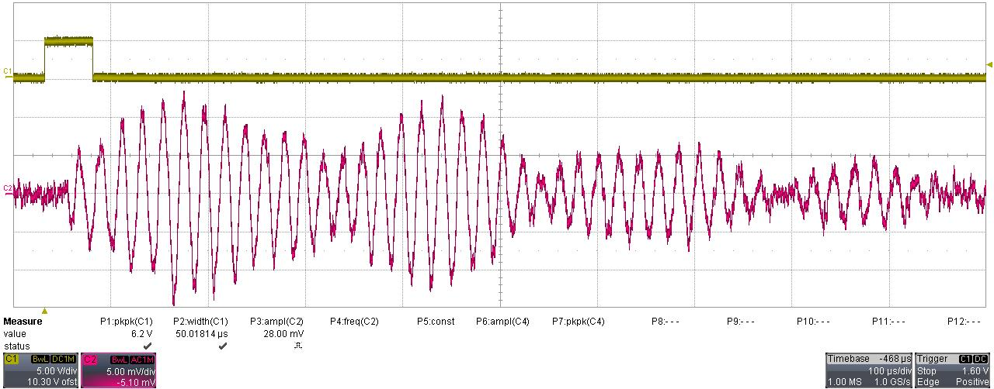

5.11 Test Condition: 200KHz, 2.5Vpp, Cycles=5, Duty Cycle=10ms, Gain=100.

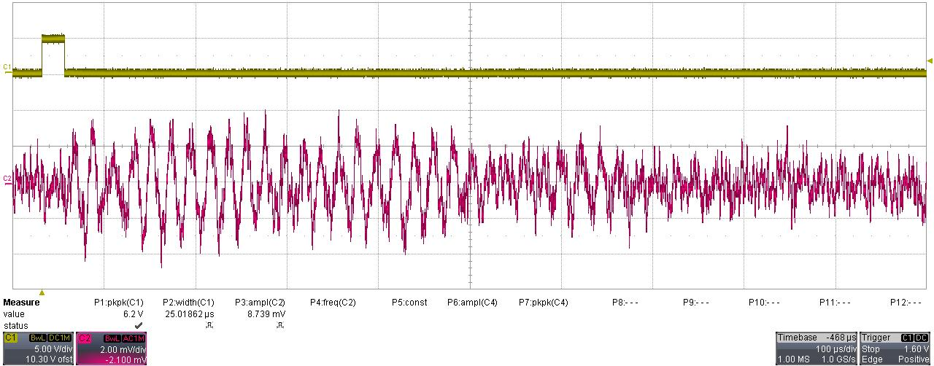

5.12 Test Condition: 300KHz, 2.5Vpp, Cycles=5, Duty Cycle=10ms, Gain=100.

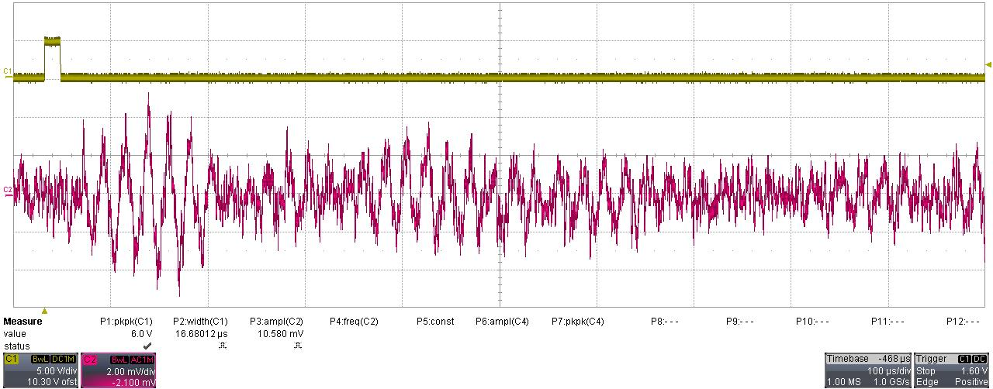

5.13 Test Condition: 400KHz, 2.5Vpp, Cycles=5, Duty Cycle=10ms, Gain=100.
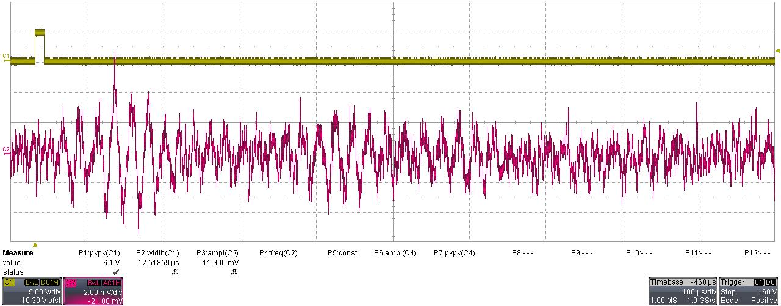

5.14 Test Condition: 500KHz, 2.5Vpp, Cycles=5, Duty Cycle=10ms, Gain=100.

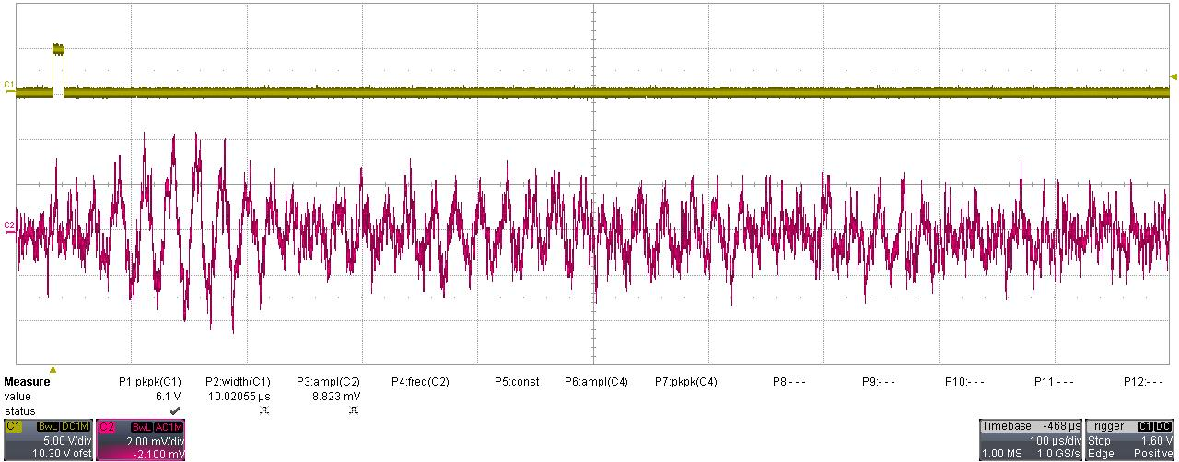

5.15 Test Condition: 600KHz, 2.5Vpp, Cycles=5, Duty Cycle=10ms, Gain=100.

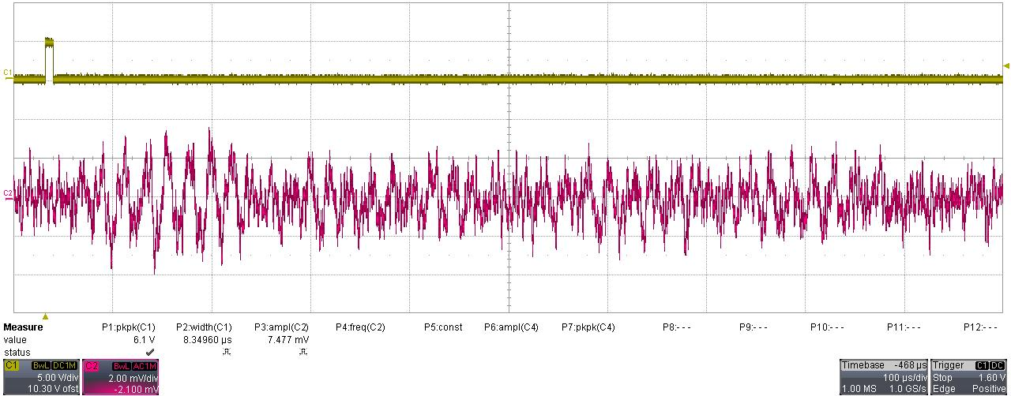

5.16 Test Condition: 700KHz, 2.5Vpp, Cycles=5, Duty Cycle=10ms, Gain=100.

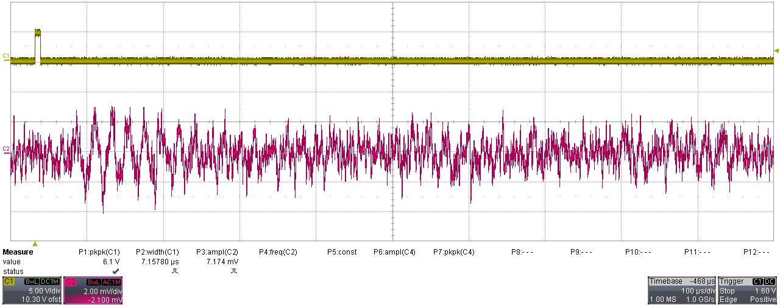

5.17 Test Condition: 800KHz, 2.5Vpp, Cycles=5, Duty Cycle=10ms, Gain=100.

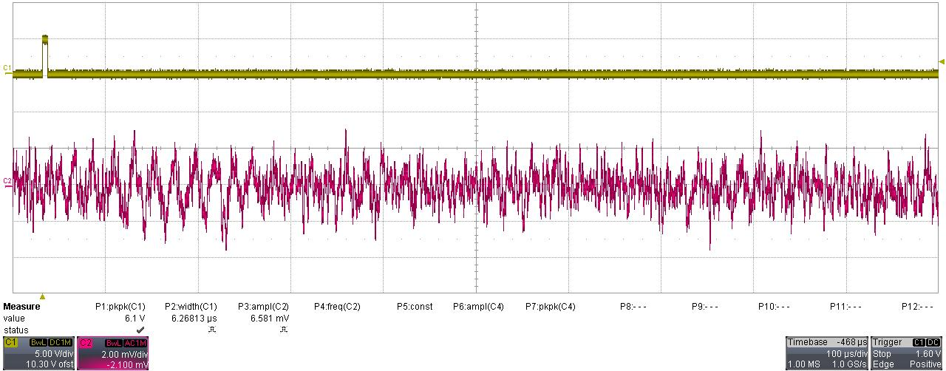

5.18 Test Condition: 900KHz, 2.5Vpp, Cycles=5, Duty Cycle=10ms, Gain=100.

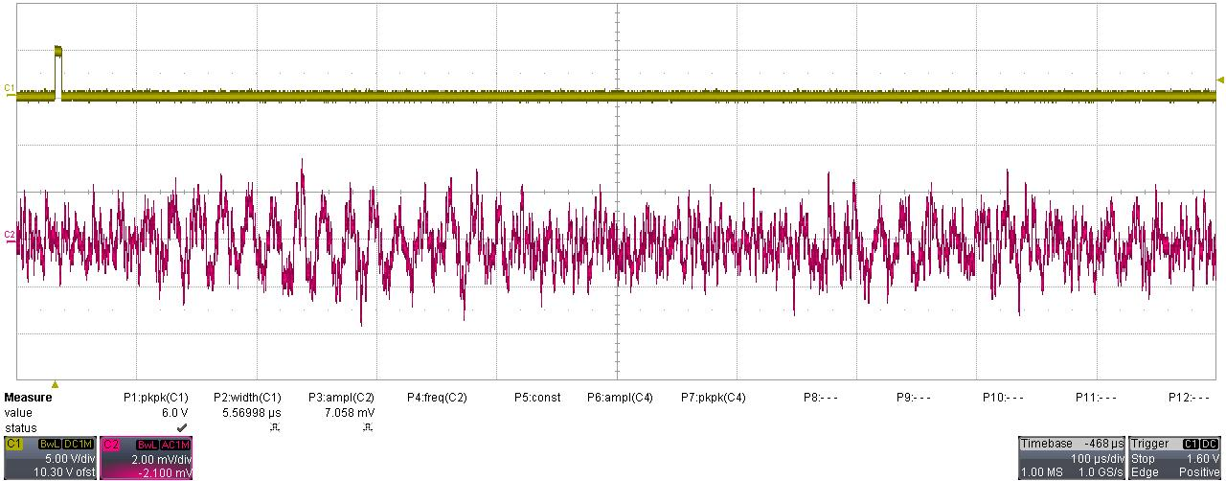

5.19 Test Condition: 1MHz, 2.5Vpp, Cycles=5, Duty Cycle=10ms, Gain=100.

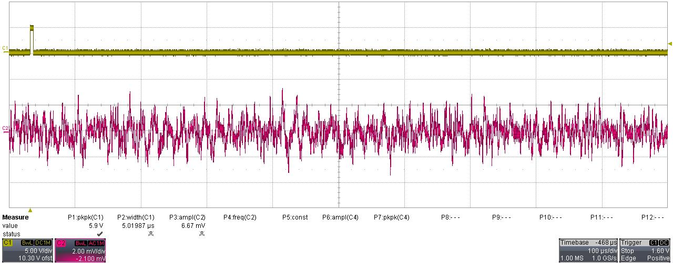

5.20 Test Condition: 40KHz, 2.5Vpp, Cycles=5, Duty Cycle=10ms, Gain=300.

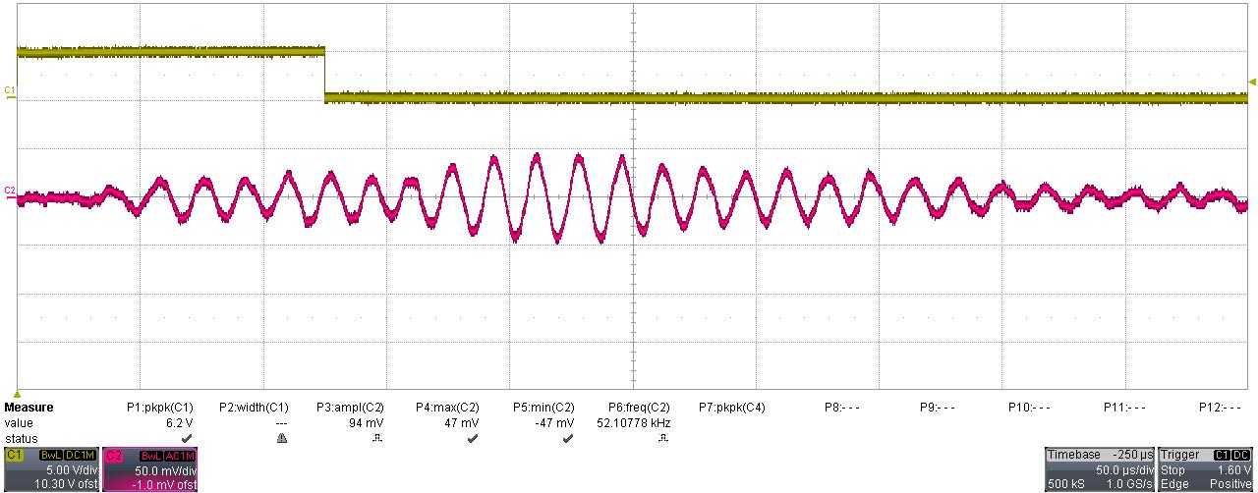
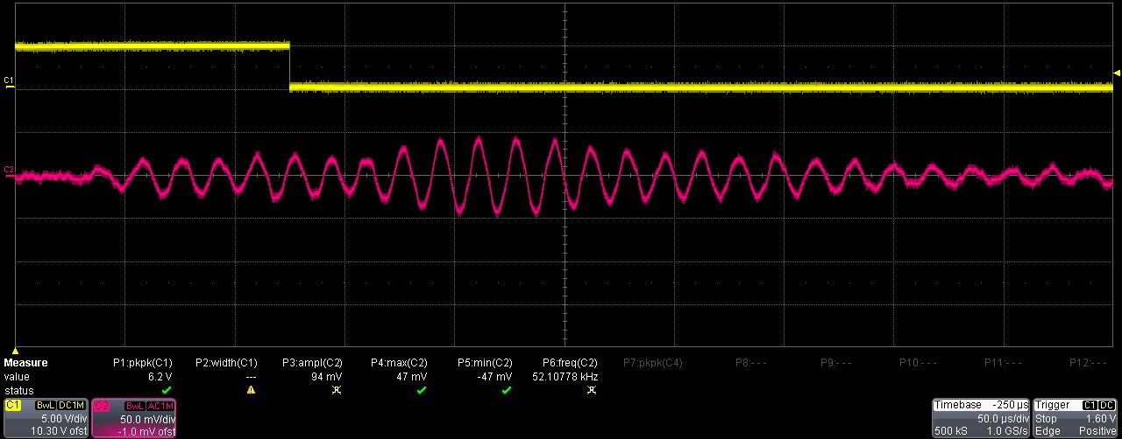

5.21 Test Condition: 50KHz, 2.5Vpp, Cycles=5, Duty Cycle=10ms, Gain=300.

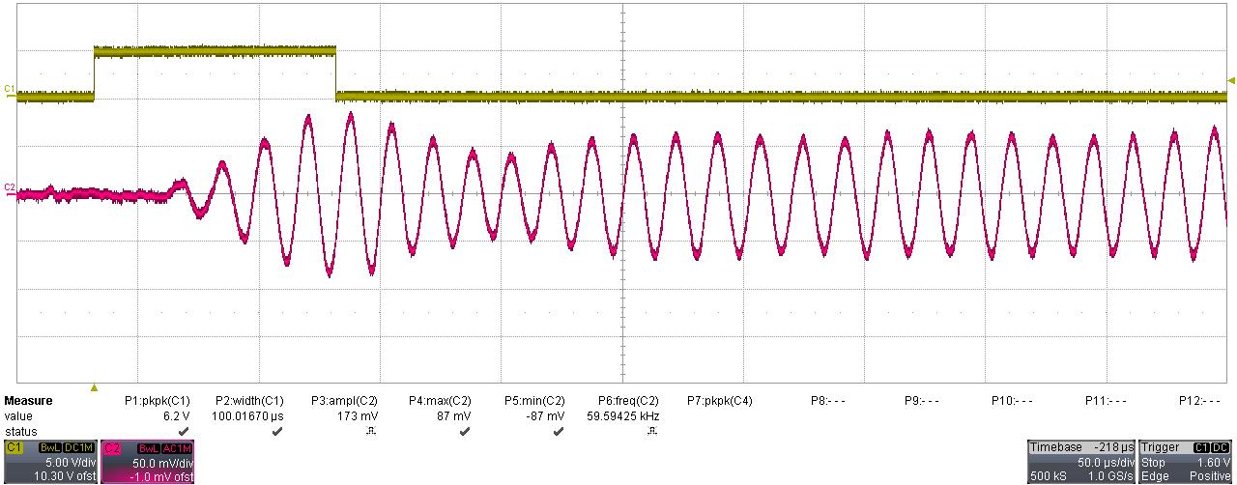
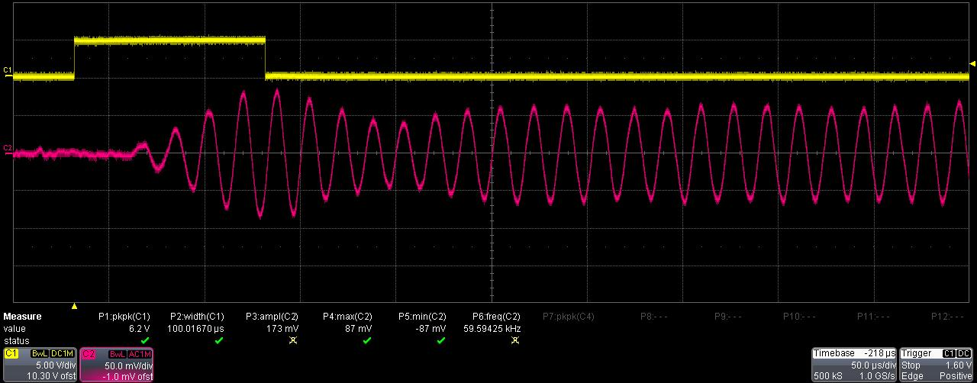

5.22 Test Condition: 60KHz, 2.5Vpp, Cycles=5, Duty Cycle=10ms, Gain=300.

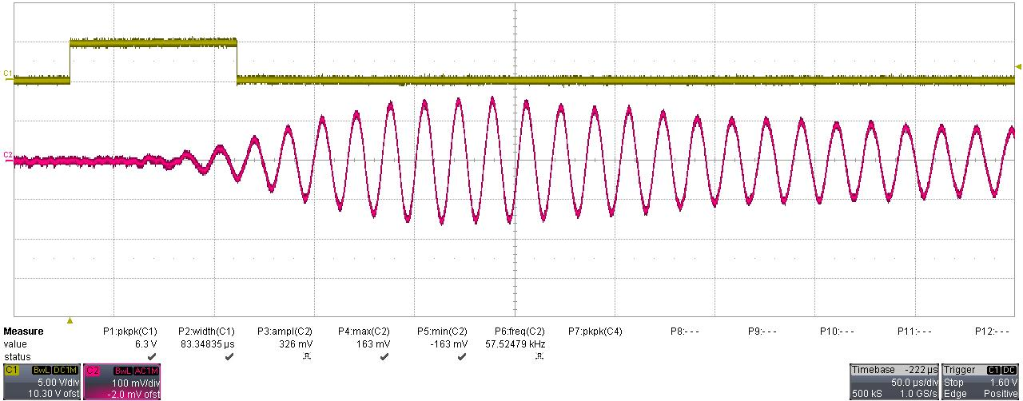
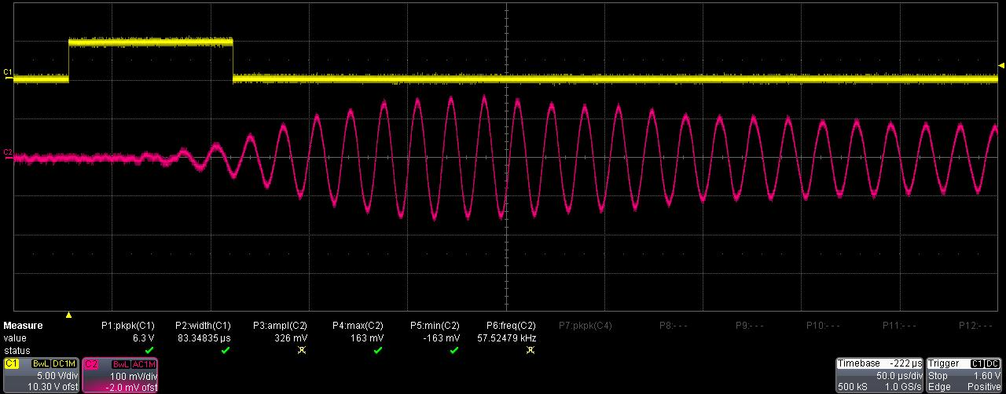
5.23 Test Condition: 70KHz, 2.5Vpp, Cycles=5, Duty Cycle=10ms, Gain=300.

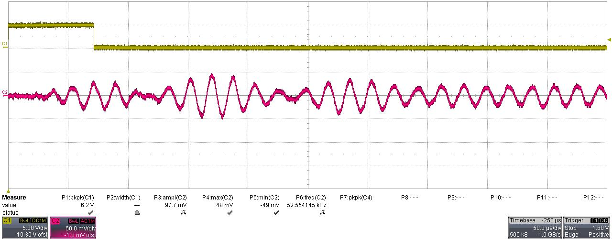
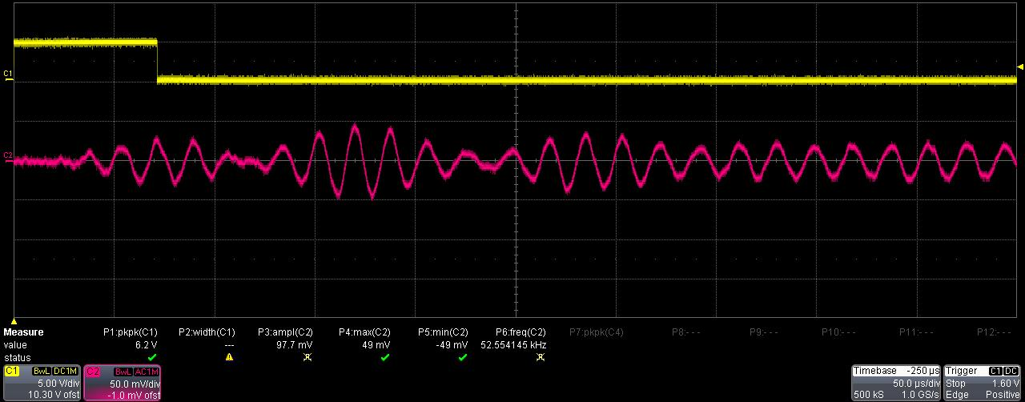

5.24 Test Condition: 80KHz, 2.5Vpp, Cycles=5, Duty Cycle=10ms, Gain=300.

